TRAINING MODELS WITH 4 SCENARIOS
================================================================================

================================================================================
SCENARIO: 80-20 Split
================================================================================
Training size: 1200, Test size: 300

Training Random Forest...
✓ Random Forest | Acc: 0.9200 | Prec: 0.7917 | Rec: 0.9500 | F1: 0.8636 | AUC: 0.9432

Training XGBoost...
✓ XGBoost | Acc: 0.9100 | Prec: 0.7849 | Rec: 0.9125 | F1: 0.8439 | AUC: 0.9448

Training LightGBM...
✓ LightGBM | Acc: 0.9200 | Prec: 0.7979 | Rec: 0.9375 | F1: 0.8621 | AUC: 0.9474

Training Gradient Boosting...
✓ Gradient Boosting | Acc: 0.9167 | Prec: 0.7957 | Rec: 0.9250 | F1: 0.8555 | AUC: 0.9470

================================================================================
SCENARIO: 70-30 Split
================================================================================
Training size: 1050, Test size: 450

Training Random Forest...
✓ Random Forest | Acc: 0.9222 | Prec: 0.7891 | Rec: 0.9667 | F1: 0.8689 | AUC: 0.9552

Training XGBoost...
✓ XGBoost | Acc: 0.9133 | Prec: 0.7755 | Rec: 0.9500 | F1: 0.8539 | AUC: 0.9505

Training LightGBM...
✓ LightGBM | Acc: 0.9156 | Prec: 0.7808 | Rec: 0.9500 | F1: 0.8571 | AUC: 0.9501

Training Gradient Boosting...
✓ Gradient Boosting | Acc: 0.9133 | Prec: 0.7832 | Rec: 0.9333 | F1: 0.8517 | AUC: 0.9533

================================================================================
SCENARIO: 60-40 Split
================================================================================
Training size: 900, Test size: 600

Training Random Forest...
✓ Random Forest | Acc: 0.9217 | Prec: 0.7811 | Rec: 0.9812 | F1: 0.8698 | AUC: 0.9553

Training XGBoost...
✓ XGBoost | Acc: 0.9167 | Prec: 0.7895 | Rec: 0.9375 | F1: 0.8571 | AUC: 0.9534

Training LightGBM...
✓ LightGBM | Acc: 0.9150 | Prec: 0.7884 | Rec: 0.9313 | F1: 0.8539 | AUC: 0.9534

Training Gradient Boosting...
✓ Gradient Boosting | Acc: 0.9150 | Prec: 0.7946 | Rec: 0.9187 | F1: 0.8522 | AUC: 0.9545

================================================================================
SCENARIO: 10-Fold Cross Validation
================================================================================

Training Random Forest with 10-Fold CV...
✓ Random Forest | Acc: 0.9173 | Prec: 0.7870 | Rec: 0.9525 | F1: 0.8610 | AUC: 0.9487

Training XGBoost with 10-Fold CV...
✓ XGBoost | Acc: 0.9160 | Prec: 0.7873 | Rec: 0.9475 | F1: 0.8584 | AUC: 0.9524

Training LightGBM with 10-Fold CV...
✓ LightGBM | Acc: 0.9147 | Prec: 0.7880 | Rec: 0.9375 | F1: 0.8552 | AUC: 0.9516

Training Gradient Boosting with 10-Fold CV...
✓ Gradient Boosting | Acc: 0.9087 | Prec: 0.7837 | Rec: 0.9125 | F1: 0.8423 | AUC: 0.9491

COMPLETE COMPARISON: ALL MODELS × ALL SCENARIOS (Sorted by ROC-AUC)
================================================================================
Scenario Model Accuracy Precision Recall F1-Score ROC-AUC
60-40 Split Random Forest 0.921667 0.781095 0.981250 0.869806 0.955341
70-30 Split Random Forest 0.922222 0.789116 0.966667 0.868914 0.955202
60-40 Split Gradient Boosting 0.915000 0.794595 0.918750 0.852174 0.954467
60-40 Split XGBoost 0.916667 0.789474 0.937500 0.857143 0.953445
60-40 Split LightGBM 0.915000 0.788360 0.931250 0.853868 0.953445
70-30 Split Gradient Boosting 0.913333 0.783217 0.933333 0.851711 0.953321
10-Fold CV XGBoost 0.916000 0.787289 0.947500 0.858393 0.952420
10-Fold CV LightGBM 0.914667 0.788009 0.937500 0.855240 0.951636
70-30 Split XGBoost 0.913333 0.775510 0.950000 0.853933 0.950530
70-30 Split LightGBM 0.915556 0.780822 0.950000 0.857143 0.950051
10-Fold CV Gradient Boosting 0.908667 0.783661 0.912500 0.842251 0.949091
10-Fold CV Random Forest 0.917333 0.786991 0.952500 0.861047 0.948727
80-20 Split LightGBM 0.920000 0.797872 0.937500 0.862069 0.947386
80-20 Split Gradient Boosting 0.916667 0.795699 0.925000 0.855491 0.947045
80-20 Split XGBoost 0.910000 0.784946 0.912500 0.843931 0.944830
80-20 Split Random Forest 0.920000 0.791667 0.950000 0.863636 0.943239

SUMMARY BY SCENARIO (Average Metrics):
================================================================================
Accuracy Precision Recall F1-Score ROC-AUC
Scenario
10-Fold CV 0.914167 0.786488 0.937500 0.854233 0.950469
60-40 Split 0.917083 0.788381 0.942187 0.858248 0.954174
70-30 Split 0.916111 0.782166 0.950000 0.857925 0.952276
80-20 Split 0.916667 0.792546 0.931250 0.856282 0.945625

SUMMARY BY MODEL (Average Metrics):
================================================================================
Accuracy Precision Recall F1-Score ROC-AUC
Model
Gradient Boosting 0.913417 0.789293 0.922396 0.850407 0.950981
LightGBM 0.916306 0.788766 0.939063 0.857080 0.950629
Random Forest 0.920306 0.787217 0.962604 0.865851 0.950627
XGBoost 0.914000 0.784305 0.936875 0.853350 0.950306

BEST MODEL:
================================================================================
Scenario: 60-40 Split
Model: Random Forest
Accuracy: 0.9217
Precision: 0.7811
Recall: 0.9812
F1-Score: 0.8698
ROC-AUC: 0.9553
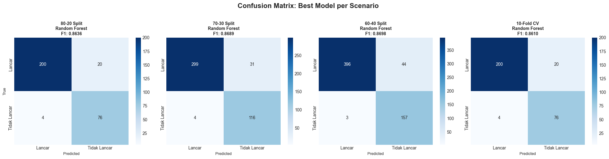
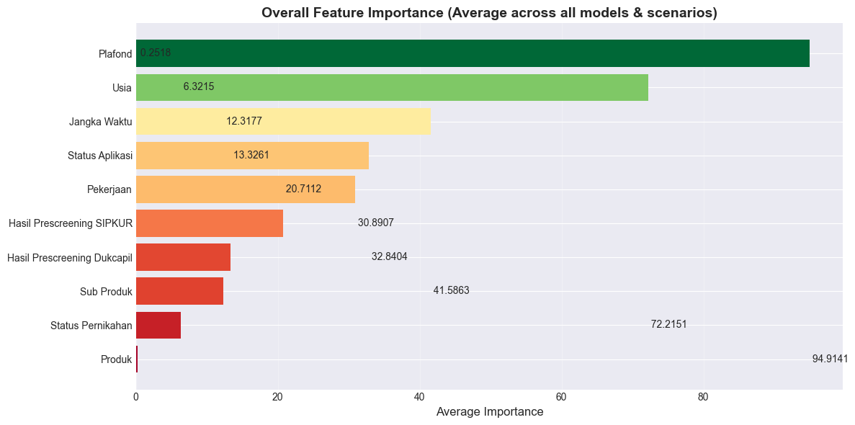

PROTOTYPE

